**LOGIC APPS**

**What is Azure Logic Apps?**

**Logic apps** is a part of Azure App Service and It is basically used to automate the access and use of data across cloud without writing any code .

* Mostly used to orchestrate Business Processes and System integration based on some workflow defined by the user .
* Logic apps is fully managed **iPAAS**(integration Platform as a service) which allows developer not to worry about building , hosting , scalability and management .

**Use Case 1**

**It’s suitable in the scenarios like when you have a predefined series of events that need to be followed in a business process,**

* **such as - if you want to replicate records from a line of business systems back to a SQL database and notify the front desk via an email; Send an SMS notification when a certain condition is met; Identify negative Tweets and post into a Slack channel. Logic Apps can help each of these scenarios and more.**

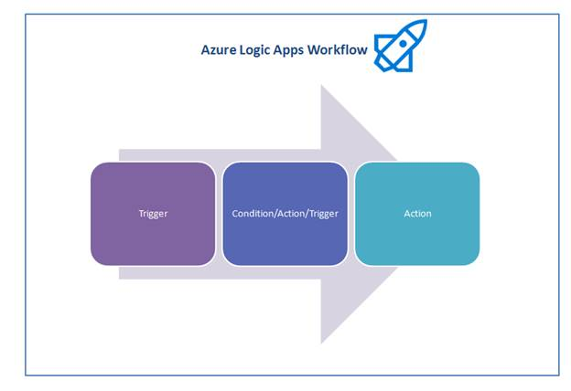

* Workflows are initiated with a “**trigger**” event, such as a particular email, or a change in an Azure Storage account.
* Workflow steps then take place as “**actions**”, which operate against a series of “**connectors**” for data flow.

1. **WORKFLOW**
   * + It is a graphical representation of a series of steps required in a business processes.
     + Constructing such workflows is now super easy with Azure App Services.
     + You can define a workflow either declaratively using a **JSON** file (which you can check-in as source code) or using the new Logic/Workflow designer introduced today within the Azure Portal.
2. **PARAMETERS**

* Parameters are things that you want to reuse across workflows. Re-using values or even complex objects throughout the definition makes it easier to comprehend.
* Separating out configuration from the definition itself makes sharing easy as well across different environments

1. **MANAGED CONNECTORS**

* Connectors are the **pre defined APIs** that you used in your processes.
* They are created specifically to aid you when you are connecting or working with your data.
* Some of the most common connectors are Bing, Google sheets, Search, Facebook, Twitter, Twilio etc.
* [**https://learn.microsoft.com/en-in/azure/connectors/apis-list**](https://learn.microsoft.com/en-in/azure/connectors/apis-list)
* If your needs are not fulfilled using the existing connectors, you can always roll on your own API app and integrate it with your logic app.

1. **TRIGGERS**

* A trigger is an event that starts the new instance of a workflow on a specific event like **adding a new record** in the database or **arrival of an email.**
* You can poll for a trigger or manually initiate it or schedule it as per your need.

1. **ACTIONS**

* Each step after the trigger in a workflow is called an action.
* Each action typically maps to an operation on your managed connector or custom API app.

**Advantages of using Logic Apps include the following,**

* + Easy and convenient to design complex processes using user friendly design tools.
  + Logical Implementation of workflow without code.
  + Many templates available for common scenario.
  + Easy to customize logic app with your own custom APIs, code, and actions
  + **Can work seamlessly with On-prem and cloud Services.**
  + Build off of BizTalk server, API Management, Azure Functions, and Azure Service Bus with first-class integration support

**Cost**

Cost of the logic app is directly related to the actions and based on the slab below it will be charged.

**Developer Tools Required**

* An Azure Subscription(Mandatory)
* Visual Studio 2013/2015 (Optional)
* Azure SDK for .Net (Optional)

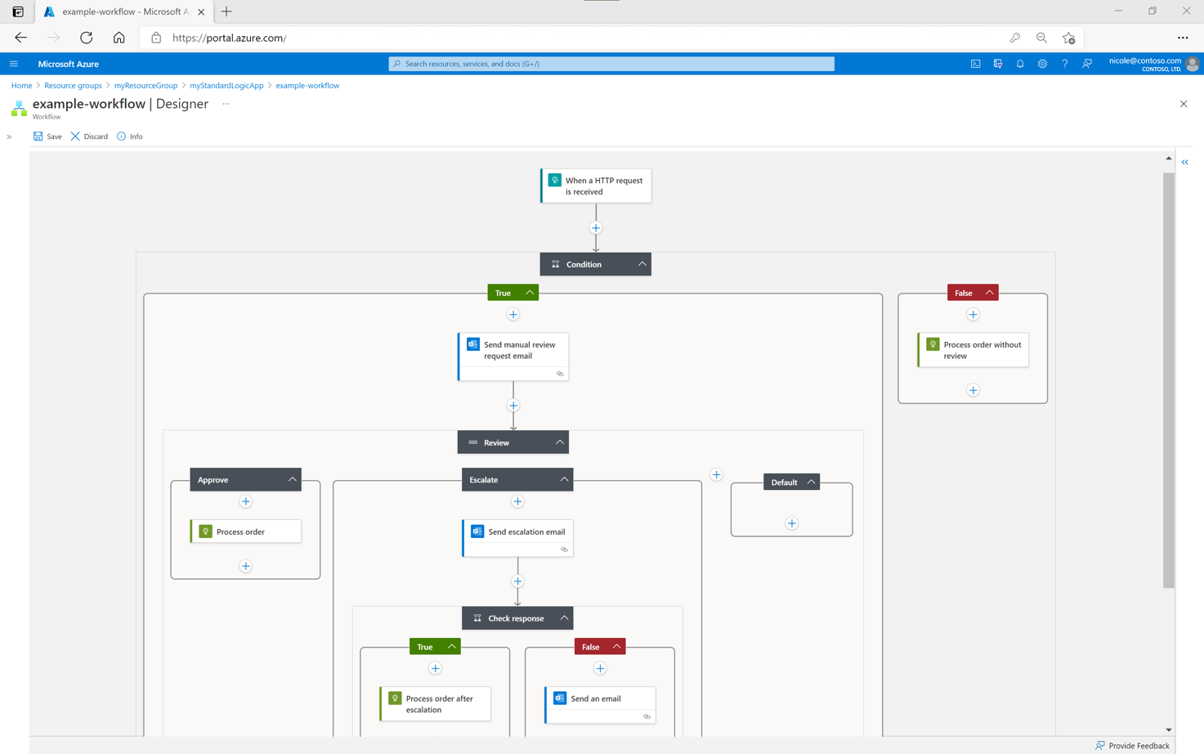

**Real time LAB-1**

**Scenario**

**We will create a sample Logic App in our Azure Portal that’s going to look out for new media in my Instagram account and post it to Facebook .**

**STEPS to Perform**

**Step 1 :**

* Go to Azure Portal and login with your credentials.
* Click on the **+** Button on the top left to add a new resource in your azure subscription and select Web + Mobile and then Select Logic Apps.

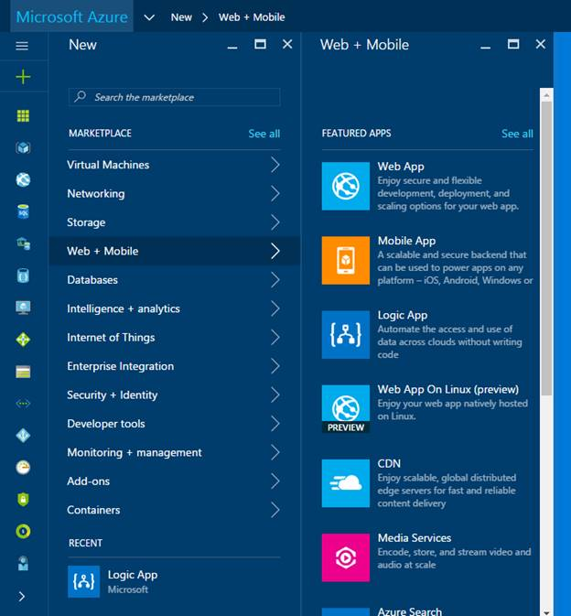

**Step 2 :**

* Give the suitable App Name along with subscription and location.
* You can select from multiple Data Centres where you want to host your logic apps.
* At present it supports 15 data centres across the globe with the majority of them located in US, Asia, Europe and Australia.
* You can select the nearest location in order to minimize network latency.

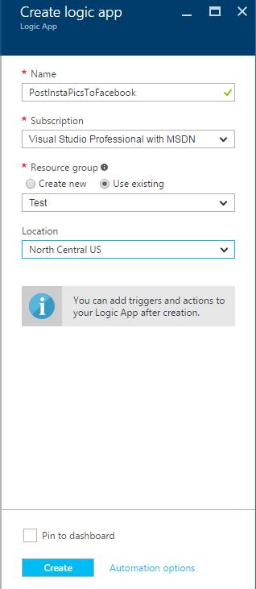

Click on **Create** button and it will start the deployment of logic apps into your resource group.

In my case I used the **resource group called Test** and the resource is created inside that resource group.

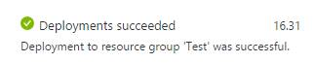

**Step 3 :**

Click on the **Edit button** on the Top or Go to the **Development Tools** and launch the **Logic App Designer .**

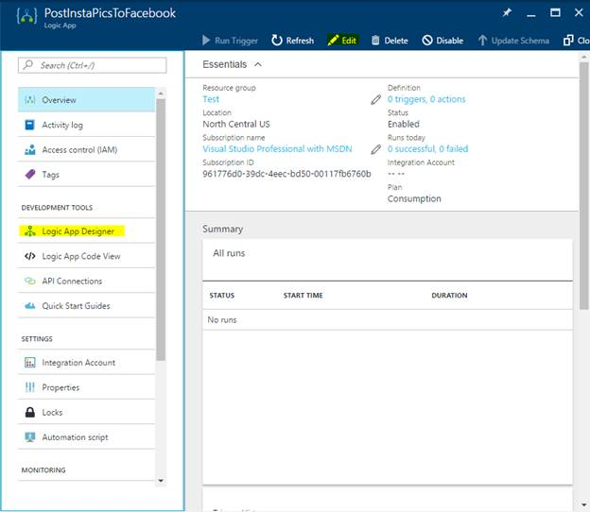

**Step 4 :**

There are multiple templates that are already present to make use of like Copying a new file from **DropBox** to **OneDrive** as soon as there is a new file upload to the dropbox account.

For our example, we need to use the **blank Logic App**.

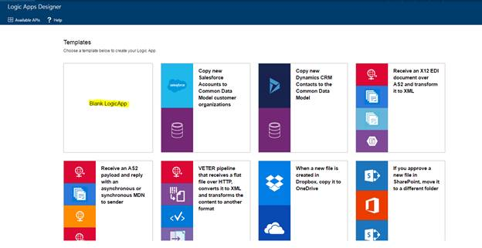

**Step 5 :**

* Here we can use the **Managed APIs** from the set of available connectors like **Office 365, VSTS, DropBox, YouTube, CRM, SalesForce** etc.
* As we discussed if we don’t want to use the Managed APIs we can use our **custom APIs hosted as Azure API APPS or Azure API Management**.

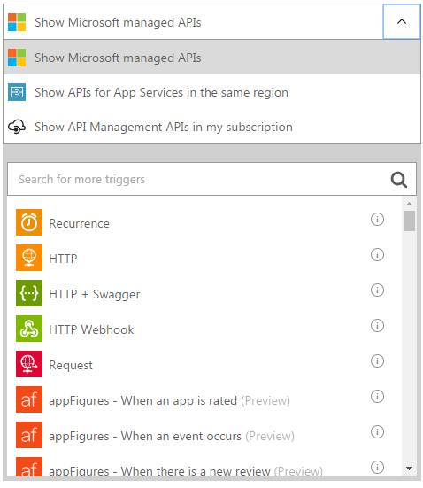

**Step 6 :**

* As we need to check if there is anything new added to the Instagram account, we need to use **Instagram Connector** and
* here it will be triggered whenever I am going to upload a new Media so this connector will keep on polling the Instagram account once and trigger this logic app when this conditions satisfies.

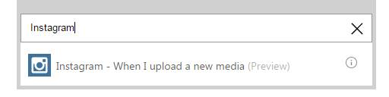

**Step 7 :**

* Click on **Sign In and Authorize** the LogicApp to use your Instagram account by logging in into the Instagram account and clicking on Allow Access.

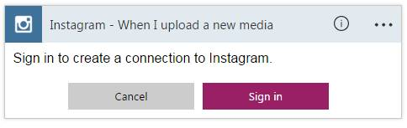

**Step 8 :**

You can choose to add a new Condition or an action and as we discussed,  **action** can act as a **Trigger** for another action or condition in a workflow.

* In our demo we are going to check if the new media has a **hastag #Facebook** associated with it then I am going to post it to my Facebook account, otherwise not.

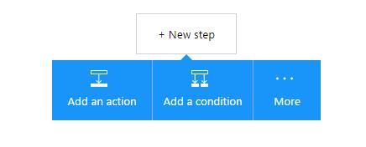

**Step 9 :**

Here we have added a condition that Tags on the media containing Facebook, then we are going to post on Facebook, otherwise not. We followed the same steps that we used in step #7 & #8 but instead of Instagram we used the Facebook Connector which posts the content to Facebook.

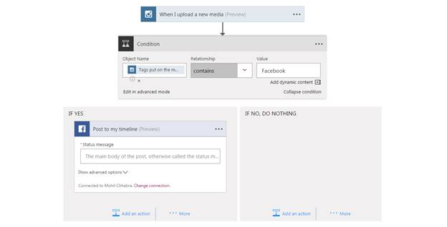

**Step 10 :**

Now you can control what you want to post on Fb using this connector. I am going to post a status message “Heya!! I just posted a new Pic on Instagram” along with the Image URI. You can also customize with your privacy settings with that post from the API settings itself. For that Just Click on the Show Advanced Options in the Facebook Connector and Enter the suitable information.

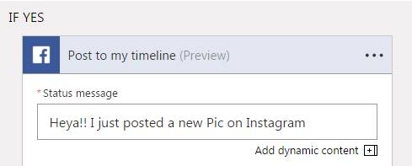

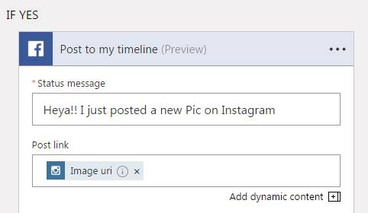

**Step 11 :**

Now our workflow is completed so we can click on **Save Button** on the Top Left of the Designer.

It will complete our Workflow and In our case we have **1 Trigger** (**new upload on Instagram account**) and based on condition we have **two actions** (**post it to fb and do nothing).**



**Step 12 :**

**Run the** **Trigger** to run the LogicApp Manually and it will start polling the Instagram account.

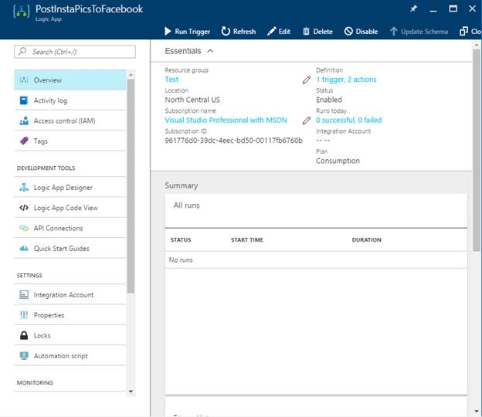

**Step 13 :**

* Now as we setup it will keep on polling my Instagram account every 1 minute and It will trigger this logic app whenever there is a new upload in my account.
* You can see that there is new job that Runs and the status of the Run is in the All Runs summary window.

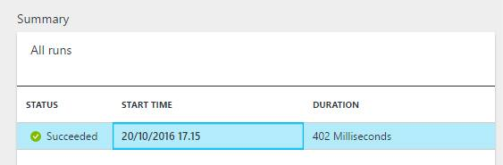

**Step 14 :**

Click on the Run to see the details of all the steps and see if our demo is successful or not.

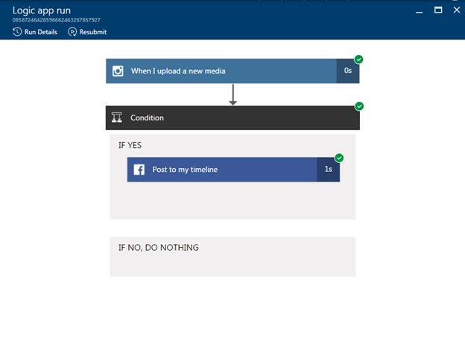

**I can further drill down to see the details of the Media in each step.**

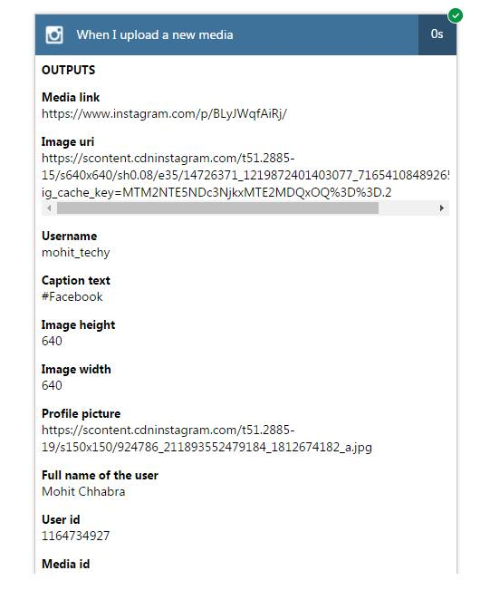

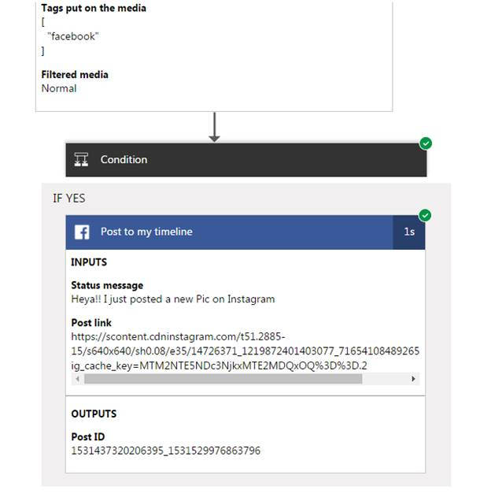

**Code**

The Designer has generated a code for the work that you have done and you can go back to the Developer Tools blade and select Logic App Code View.

The code is stored in the **JSON format** and you can directly create this JSON Template from Visual Studio and publish it to azure directly instead of using the designer on the Azure Portal.

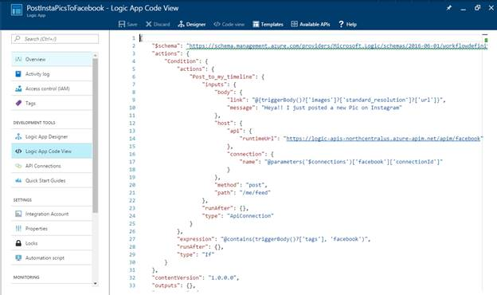

**Conclusion**

* **Azure Logic Apps** is the part of the Azure App Service and its one of the most important additions for the Enterprise Applications.
* Logic Apps are basically designed to orchestrate Business processes and System Integration.
* Logic App service is a **Code-less integration service** for communicating with different services or platforms.
* It is fully managed and with a lot of connectors available and custom APIs and you can design and orchestrate your complete business workflow.

----------- **END** -------------